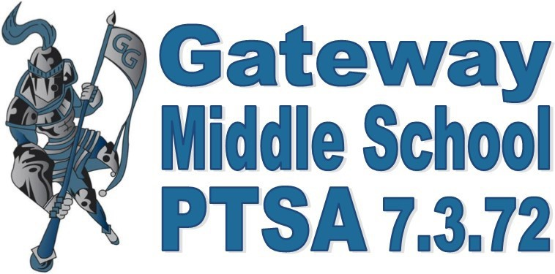
Gateway PTSA is proud to welcome all new and returning
students and families to the 2018-2019 school year.

Welcome!
Your Gateway PTSA is here to enhance and enrich the school experience of your students and our community. Together with our region, state and national PTA we provide a voice for our students.

Gateway PTSA organizes, provides services, funds and/or volunteers for many events and activities at Gateway Middle School and other organizations.

Faculty Grants | Everett Council Shoe Fund | Guardian Wear
Student Store | Student of the Month Breakfast | Staff Appreciation Events
Reflections Art Program | Guardian Award Breakfast | Operation School Bell
Box Tops for Education | Focus Day—Legislation | Presidential Volunteer Award
Guest Speakers/Family Events | 8th Grade Bridging & Celebration | June Jamboree

New this year, we are offering a membership option for students. Each adult and student membership is a sign of support for the students and staff at Gateway Middle School. PTSA membership has many benefits, but the most useful in my opinion is regular updates about what is happening at the school. Each member will receive the weekly eBlast which includes information from the Gateway PTSA, Gateway Middle School, Everett School District and community organizations. Attending PTSA meetings is not an expectation of membership, but you are always welcome to attend and your opinions and assistance are greatly appreciated! Meetings are held in the Gateway Library from 6:30-8:00 p.m. on the dates listed below.

Membership Meetings: September 10, November TBD, January 14, March 11, April 8, June 10
Board of Director Meetings: October 8, December 10, February 11, May 13

Gateway PTSA asks for a one-time PASS THE HAT donation to support PTSA programs at Gateway Middle School. Any donation amount is appreciated and your donation is tax-deductible! If you work for an employer that offers corporate matching, we can assist you with the paperwork to obtain the matching funds.

Gateway PTSA would like to thank you for your interest and hopes that you support our efforts by becoming a member today. A Gateway PTSA membership form is included in this packet for your convenience.
The 2018-2019 Gateway PTSA Executive Committee,
Kori Dewing - President
Larissa Pfeifer – VP Volunteers
Andrea Rosen – VP Fundraising
Hai Evans - Treasurer
Debi Kobylk - Secretary
Heather Emans - Membership

