Gateway PTSA 2024 Award Nomination Form
for Golden Acorn, Outstanding Advocate, Outstanding Student Advocate, & Outstanding Educator

Gateway PTSA takes pride in all our outstanding volunteers and staff members that make Gateway Middle School a great school. What better way to thank these incredible individuals than to acknowledge them with one of the most prestigious awards available from Washington State PTA? These awards have been presented at Gateway to volunteers and educators for their outstanding volunteer service, advocacy work, and commitment to all children. Gateway PTSA asks that you take the time to read through each of the award descriptions and consider nominating an individual that you think is worthy of recognition for their service and dedication to not only the children at Gateway, but to all children.

The Award descriptions are listed below with the nomination form on the next page. Also, an individual is not eligible to receive a duplicate award but can receive an award in another category. Previous award recipients are listed at the bottom of this page. Online option: http://tiny.cc/qwnjxz Completed and signed nomination forms should be submitted in a sealed enveloped marked "PTSA Awards" by: March 29, 2024
Golden Acorn Award
The Golden Acorn Award is presented to a volunteer in recognition of their outstanding service to all children in a school community; for volunteer service that goes "above and beyond" a particular job description; and for continued service to PTA, local church, school, sport organizations, and/or youth organizations.
Outstanding Educator Award
Award is offered by Washington State PTA and presented by a local PTA unit to an individual who has not only provided outstanding educational opportunities for children and youth but goes beyond the normal scope of their job and makes the learning environment fun, beneficial, and challenging.
Outstanding Advocate Award
Recipients demonstrate a commitment to helping create strong policies relating to the health, welfare, safety, and education of ALL children and youth through PTA legislation, private organizations, education and/or community outreach programs. Recipients may have sponsored food drives, lead children's programs or been involved in important PTA issues.
Outstanding Student Advocate Award
The Outstanding Student Advocate is presented by a local PTA unit or council or region to recognize students who have made significant contributions through leadership and service in their schools and community.

Golden Acorn Award Recipients: 2023–Stephanie Poole & Lisa Syravong ~ 2022-Eileen Sugimoto ~ 2021-Melissa Hinze & Hai Evans ~ 2020-Kori Dewing ~ 2019-Larissa Pfeifer & Lea Anderson ~ 2018- Angela & Charlie Fix~2017 Heather Emans & Lona Brask ~ 2016 Jennifer Rosholt ~ 2015 Brick Baldwin ~ 2014 Angela Harris & Taleena Koch ~ 2013 Vicki Fraser & Luanne Te ~ 2012 Kelley Phan ~ 2011 Heidi Panell ~ 2010 Liza Granada ~ 2009 Kris Helgerson & Sharon Loch ~ 2008 Dori Mashburn & Laura McGinnis ~ 2006 Tammy Gurwell ~ 2004 Mildred Van de Carr

Outstanding Advocate Award Recipients: 2023-​Elizabeth Sanchez ~ 2022-Matt Bennett ~ 2021-Diane Indivero ~ 2020-Andrea Rosen ~ 2018 Kathy Pace ~ 2017 Jessen Schilaty ~ 2016 Lisa Mills & Laura Peterson ~ 2015 Denise Constantineau ~ 2014 Shelley Petillo ~ 2013 Jocelyn Smith ~ 2012 Cheri Miller-Burkhardt ~ 2011 Pam James ~ 2009 Mary Donnelly ~ 2008 Eldon Allen & Lorie Lambert ~ 2007 Jeff Heckathorn & Jerry Washington

Outstanding Educator Award Recipients: 2023-Jeri Timmons-Tharp & Thomas Morgan ~ 2022- Dyann Swaney & Jane Horton ~ 2021-Brittany Griffin & Rebecca Miller ~ 2020-Jennifer Van Tuyl, Pamela Weaver, 2019 Patricia Weber, Paul Rentko, Kathi Gratz~2018 Monika Tabor, Janaya Almquist ~2017 Michelle Walsh & Gretchen Stoskopf-Hedges ~ 2016 Laura Fullner-Grennan & Jessica Sowa ~ 2014 Jennifer Murk ~ 2013 Diana Arango & Brenda Bakke ~ 2012 Justin Tonnes-Priddy & Patty Personius ~ 2011 Lance Palmer 2010 Peter Scott ~ 2009 Jason Lunder, Stacy Stephens, & Kim Demetre ~ 2008 Cheyenne Beck & Elizabeth Nunes ~ 2007 Scott Boal & Pattie Holt ~ 2006 Jessica Lutthans ~ 2005 Cathy Woods & Joyce Isaman ~ 2003 Stacy Dachenhausen ~ 2001 Lois Craig

Outstanding Student Advocate Award Recipients: 2023-Gino DiPasquale ​& Sahaja Kakumanu ~ 2022-Lily Mahon ~ 2021-Mya Cato & Chloe Kimiko Gushiken

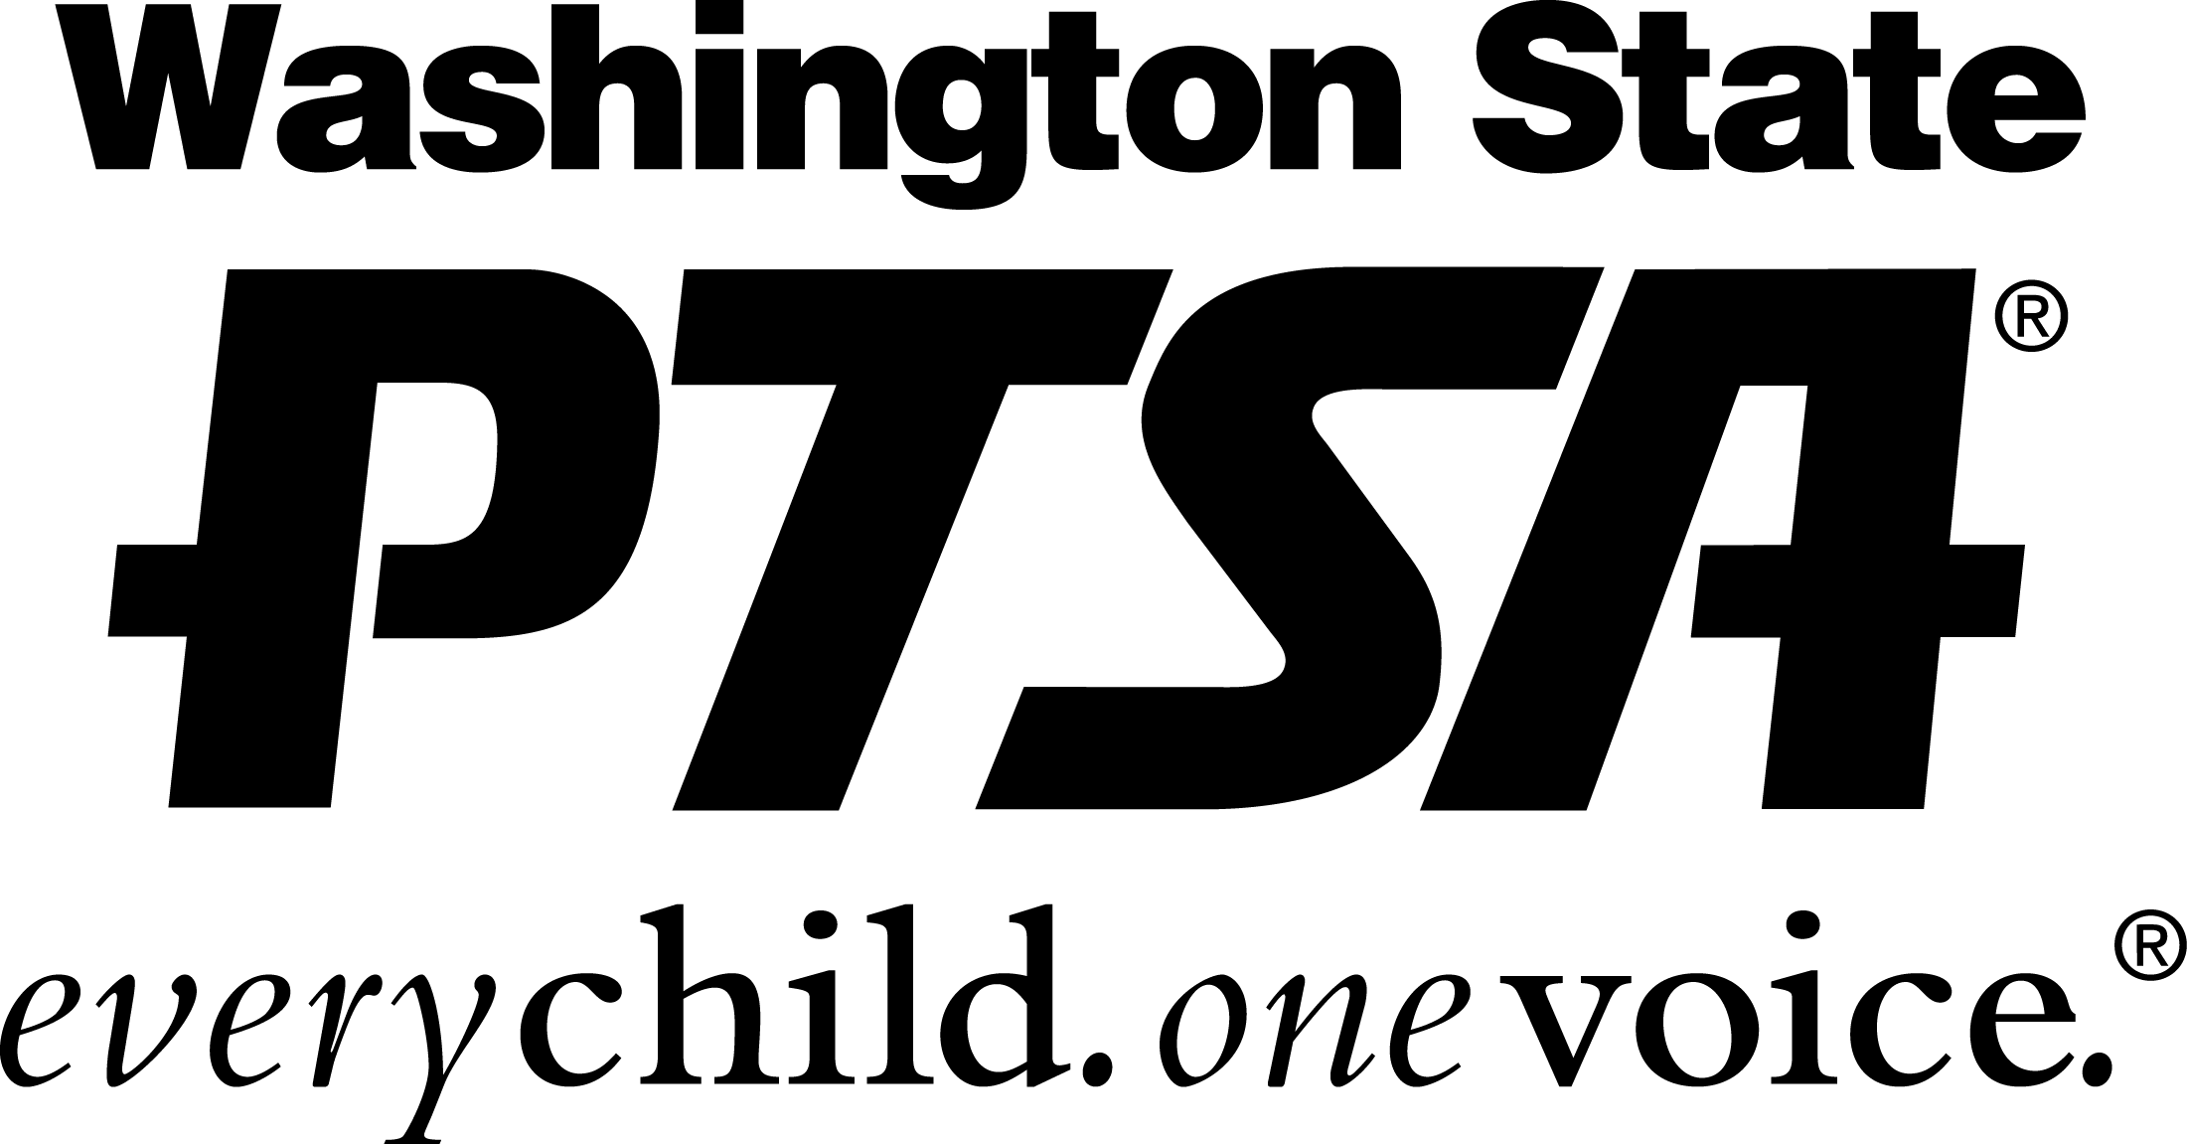
Nominations are accepted for all awards, though each award may not be presented annually. The awards committee is appointed by the President, and typically consists of past recipients. All nominations will be taken under consideration; however, final decisions rest with the committee. Thank you!
Gateway PTSA 2024 Award Nomination Form
for Golden Acorn, Outstanding Advocate, Outstanding Student Advocate, & Outstanding Educator

I would like to nominate:
(Please print name clearly — first and last.)

Please check the box for the appropriate award:
☐ Golden Acorn ☐ Outstanding Advocate
☐ Outstanding Educator ☐ Outstanding Student Advocate

Please describe why you feel this individual is deserving of this award (attach another sheet if necessary):

Please return your completed nomination form in a sealed envelope addressed to: "PTSA Awards" by Friday, March 29, 2024. You do not have to nominate an individual in each category for your nomination form to count. Additionally, you may nominate more than one individual in any category. Additional forms are available in the bins by the front office. Please remember to give examples for each nomination and sign the nomination form in the space below. Only signed nomination forms will be accepted. Nominators are kept confidential, only your kind words are passed along. Students are welcome to submit nominations.
Signed___________________________ Print Name_________________________
Contact #/email ___________________________
For additional information or questions please contact Gateway MS PTSA: gatewayptsa7.3.72@gmail.com

Thank you!

